Countdown Timer

CSE321 Fall 2021: Project 2

Misha Nelyubov

October 31, 2021

Table of Contents

01. Introduction 1

02. Specifications 1

03. Features 2

04. Applications 2

05. Block Diagram 3

06. Functionality Diagram 3

07. Bill of Materials 4

08. Schematic 4

09. Test Plan 6

10. Results 7

11. Recommendations for Improvement 7

# Introduction

This document describes the implementation and use of a countdown timer and alarm system. The timer uses a 4x4 keypad for user input, supports a countdown duration of up to 9 minutes and 59 seconds, displays the current state of the system on an LCD, and uses a set of LEDs to indicate that time is up.

# Specifications

The system has the following characteristics and constraints:

* The system must be powered by a 5V DC connection to the Nucleo board.
* The inputs to the system are the keys labeled 0-9, A, B, and D on a 4x4 matrix keypad.
* Input digits are entered into the seconds digit and shifted left to the tens of seconds and then minutes by subsequent numeric inputs.
* Any duration input of more than three digits will be truncated to the most recent three digits.
* Maximum timer duration: 9 minutes and 59 seconds. Any inputs above this duration will be reduced to 9:59.
* Allows up to 99 seconds as an input when total duration will be less than 10 minutes.
* When the timer is not already started, pressing A will start the timer.
* When counting down or when the alarm is triggered, pressing B will stop the timer or alarm.
* When not counting down, pressing D will prompt for a new input time, resetting the duration to 0:00 until subsequent input.
* When already in input mode, pressing D will reset the input duration to 0:00.
* Output text will display on an LCD to indicate input time, remaining time, that the alarm is going off, or that the timer is stopped.
* The input detection LED will light up for as long as any button press is detected, regardless of if the button press will have an effect on the system.

# Features

* LCD displays timer mode and countdown time.
* 16-character keypad for user input.
* Alarm LEDs indicate when timer has counted down to zero.
* Last input duration preserved for easy repeated countdowns.
* Programmable countdown duration to the second.

# Applications

This system can be utilized in a context where a countdown with a duration of less than 10 minutes is required and where a purely visual alarm that the designated time has elapsed are sufficient. Some example use cases are provided:

* Using this timer as an indicator to not interact with something in proximity of the timer until the time has elapsed.
  + E.g. A chemical reaction takes five minutes to be considered safe to interact with. The timer can be run for five minutes, and the times up screen can act as an indicator that it is safe to proceed with appropriate use of the chemical.
* Using the active alarm LEDs when the timer duration has expired to be informed that what the timer was associated with is ready to be checked up on.
  + E.g. A subroutine without a user interface takes eight minutes to complete. After beginning the subroutine, begin the timer. Once the Alarm LEDs are active, this indicates that the subroutine should be done, and subsequent work with the system can proceed.
* Repeat use of the timer with short durations can be used to assist in managing time spent on each individual step of a task.
  + E.g. A two-hour open-resource exam is given such that an average of only 90 seconds can be spent on each individual question. Starting the timer at the beginning of each question can indicate when average time has elapsed and it is recommended to move on.

# Block Diagram

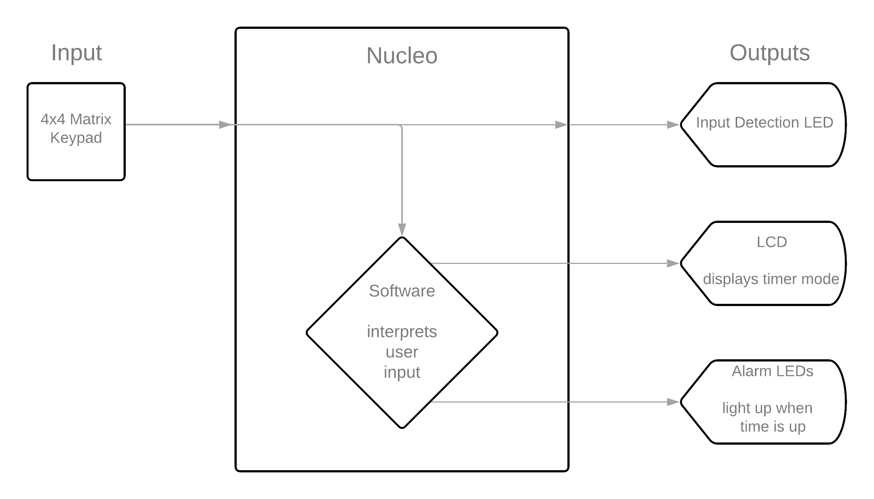

# Functionality Diagram

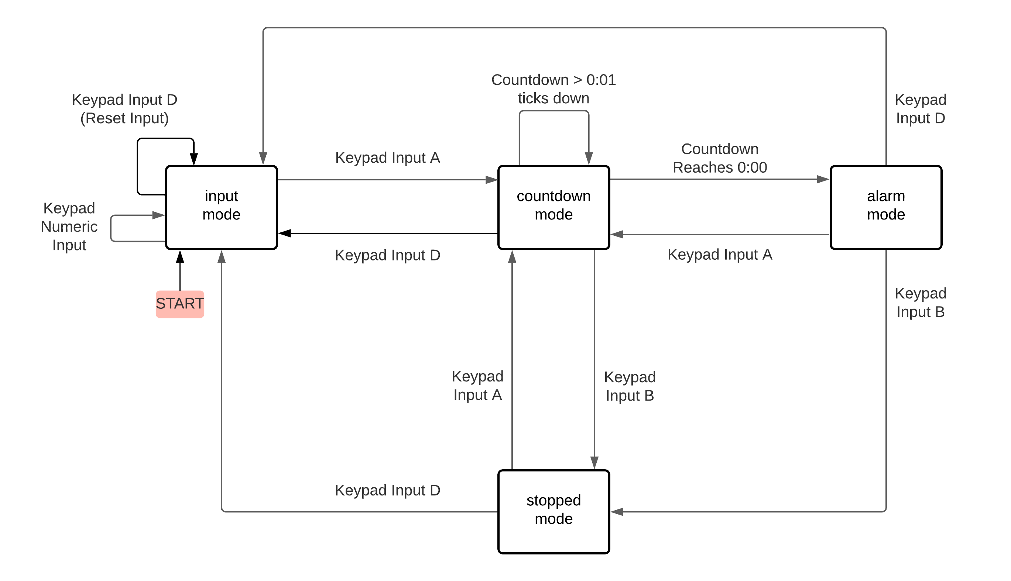

# Bill of Materials

The following hardware will be required to create the timer:

* NUCLEO L4R5ZI microcontroller
* 4x4 matrix keypad (8-pin)
* JHD1804 LCD
* Solderless breadboard
* USB 2.0 A to USB 2.0 Micro B cable
* Four (4) LEDs
* Eight (8) 1kΩ resistors
* Jumper wires (recommended to have at least 14)

# Schematic

The following set of schematics describes the set of electrical connections between the NUCLEO and peripheral devices required to create the timer.

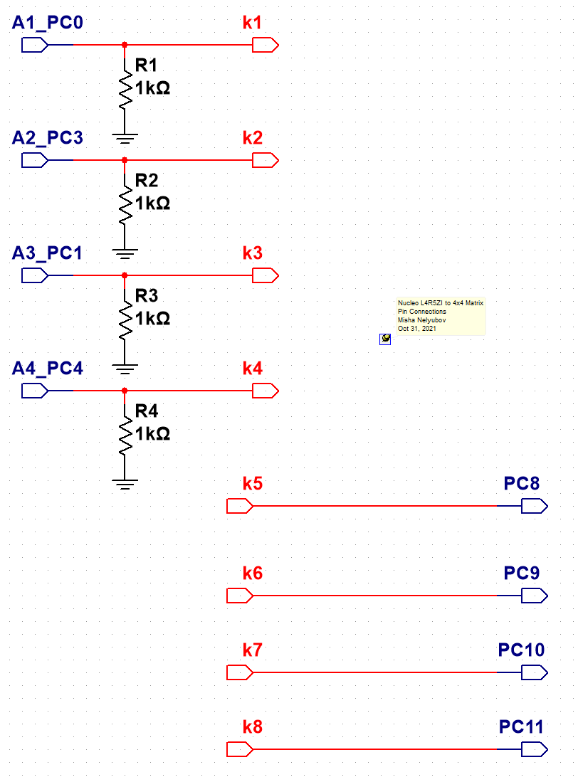

Schematic 1. The eight pin connections between the NUCLEO microcontroller and 4x4 matrix keypad. Connectors k1-k8 represent pins 1-8 of the matrix keypad.

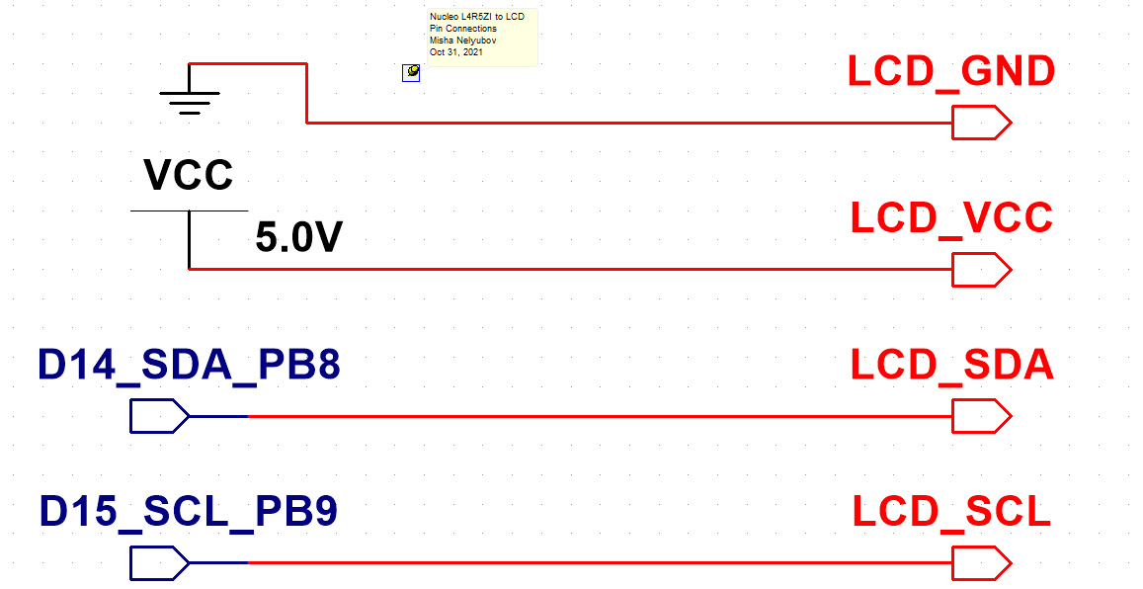

Schematic 2. The four pin connections between the NUCLEO microcontroller and LCD.

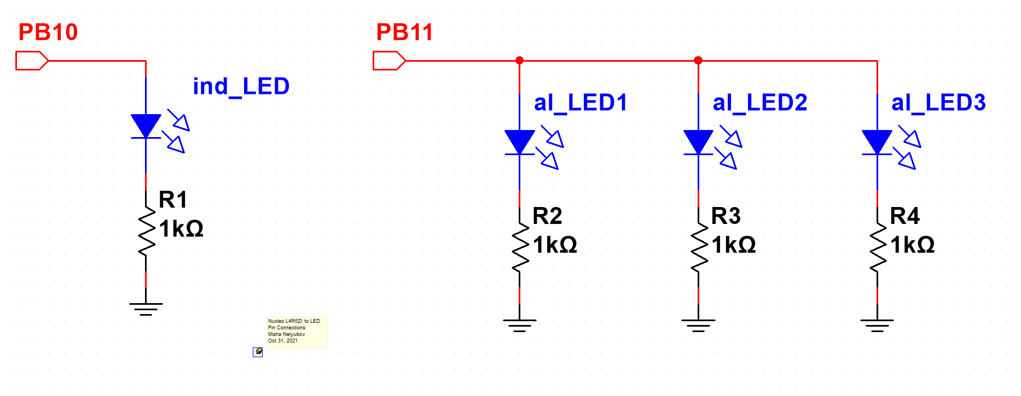

Schematic 3. The two pin connections between the NUCLEO microcontroller and the indicator and alarm LEDs.

# Test Plan

After assembling the system as per the schematics, loading the code into the Nucleo, and turning on the system, the following instructions are used to verify the functionality of the built system:

1. Upon turning on, the LCD should display “Input Duration” on the top row of the LCD and “of timer: 0:00” on the bottom row of the LCD.
   1. If no LCD text is visible, the LCD may not be properly connected to all four terminals. Make sure that VCC connects to a 5V pin, GND connects to a ground like that also connects to a ground pin on the Nucleo, and that the SDA/SCL pins are not backwards.
   2. If a different value is appearing instead of 0:00 in the bottom row, make sure that all four ground connections between the keypad channels 1, 2, 3, and 4 are connected to a common ground with one resistor making this connection for each channel.
2. Press and Hold the button labeled “1” on the keypad.
   1. Verify that the text displayed on the bottom row becomes “of timer: 0:01”.
      1. If something different is displayed, verify that the pin connections between the keypad and Nucleo have all been mapped exactly as described in Schematic 1.
   2. Verify that the single “Input Detected” LED is illuminated.
      1. If the LED does not turn on, verify that its cathode is connected through a resistor to the common ground and that its anode is connected to Pin 11 of Port B.
3. Release the button labeled 1.
   1. Verify that the single “Input Detected” LED is turned off.
4. Press the “A” key on the keypad.
   1. Verify that the LCD text switches to “Time Remaining” in the top row and “0:00” in the bottom row for 1 second.
   2. Verify that the LCD text then switches to have no text in the top row and “Times up” in the bottom row and that the three Alarm LCDs are all illuminated.
5. Press the “B” key on the keypad to stop the alarm.
   1. Verify that the Alarm LCDs have turned off.
   2. Verify that the text displayed on the LCD switches to “TIMER STOPPED” in the top row and that the bottom row is empty.
6. Press the “D” key on the keypad to return to the Input Mode.
   1. Verify that the LCD is displaying the same text as it did in step 1 and that the input time is currently 0:00.
7. Press the keys “1”, “2”, then “3” in sequence.
   1. Verify that the input time on the second line becomes “0:01” then “0:12” and finally “1:23” after each keystroke.
8. Press the “A” key to start the timer. Allow the timer to count down to less than a minute to verify proper handling of significant figure shifts.
9. Before the timer reaches 0, press the “B” key.
   1. Verify that the text displayed on the LCD switches to “TIMER STOPPED” in the top row and that the bottom row is empty.
10. Press the “A” key to restart the timer.
    1. Verify that the timer begins ticking down from the last input time, 1:23. The first displayed output time should be “1:22”.

# Results

With all circuit connections established and the program loaded onto the Nucleo, the system operates as expected.

From startup, pressing the button “1” will cause the input timer duration to be set to “0:01” and cause the input detection LED to light up for the duration of the button press.

Pressing the button “A” will cause the timer to switch to the countdown mode for one second and then switch again to the alarm mode, lighting up the three alarm LEDs.

When the timer alarm is active, pressing the button “B” will stop the alarm.

When the timer is stopped, pressing the button “A” will restart the countdown with the last input time.

When the timer is stopped, pressing the button “D” will return the timer to the input mode where a new timer duration can be entered.

When the timer is in input mode, entering the button sequence “123A” will cause the timer to start a countdown from 1 minute and 23 seconds down to 0 seconds, at which point the timer will stop, the LCD will display that “times up”, and the three alarm LEDs will light up.

If the button “B” is pressed while the timer is still counting down, the countdown timer will be stopped and present the same “TIMER STOPPED” message as when the alarm is shut down.

When the timer alarm is active, pressing the button “D” will stop the alarm and return the timer to the input mode where a new time can be entered. The last input time is cleared when “D” is pressed.­

When the timer alarm is active, pressing the button “A” will stop the alarm and begin the timer again with the latest input duration.

# Recommendations for Improvement

The timer currently suffers from several constraints. The following recommendations are given for consideration in future revisions:

1. Increase the maximum duration of the timer to be greater than 9 minutes and 59 seconds, thus allowing the system to be used for longer-duration applications.
2. Add a paused mode between the countdown and stopped modes where the time being counted down is paused, but not cleared. From this mode, allow the countdown to be resumed from its paused value by pressing A or fully cleared back to the stopped mode by pressing B again.
3. Add an audio output component for the alarm so that users in proximity of the system can be alerted to the remaining time reaching zero without the need to be looking at the system to recognize that this is the case.